# Demo 2 - Incident Enrichment in ServiceNow for VM in Azure

## Pre-Work

Server in resource group

Create CMDB Record

## Live Demo

## Show creating an incident FIRST!, talk through the scenario.

1. Create logic app with web hook

{

"id": "9e7f9864532023004247ddeeff7b121f",

"type": "EnrichIncident"

}

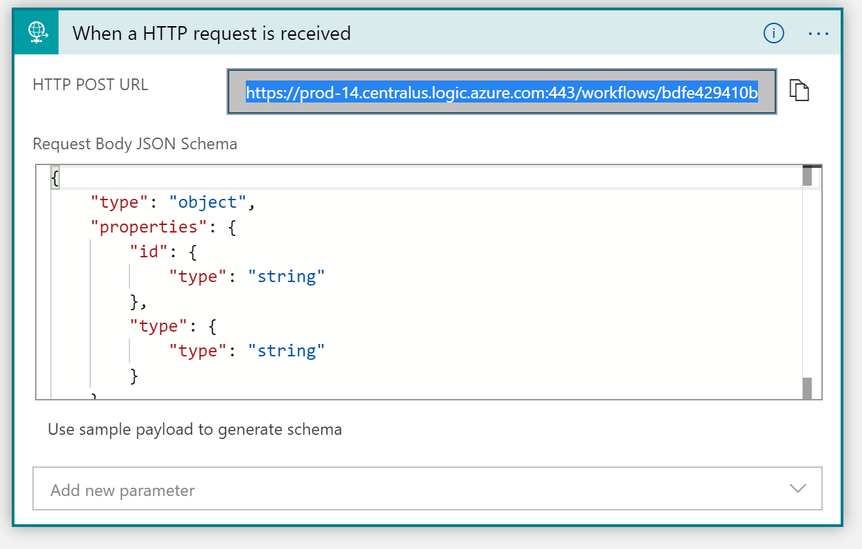

1. Create ServiceNow Action and flow

“NICCONF_4_SendINCCreateNotification”

Add action inputs: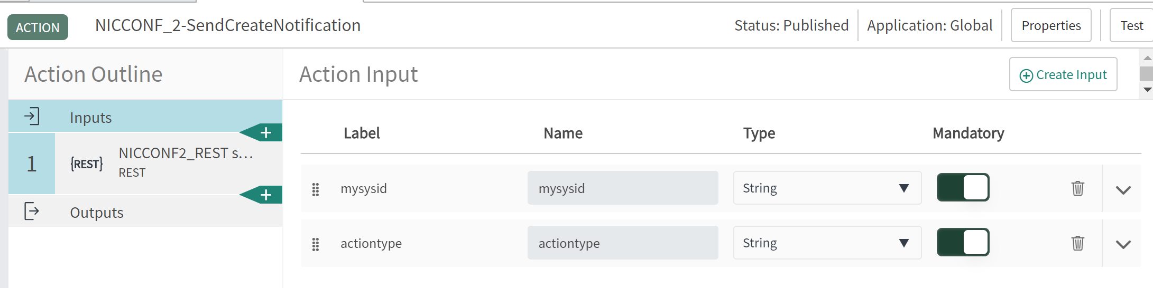

Create the rest step: 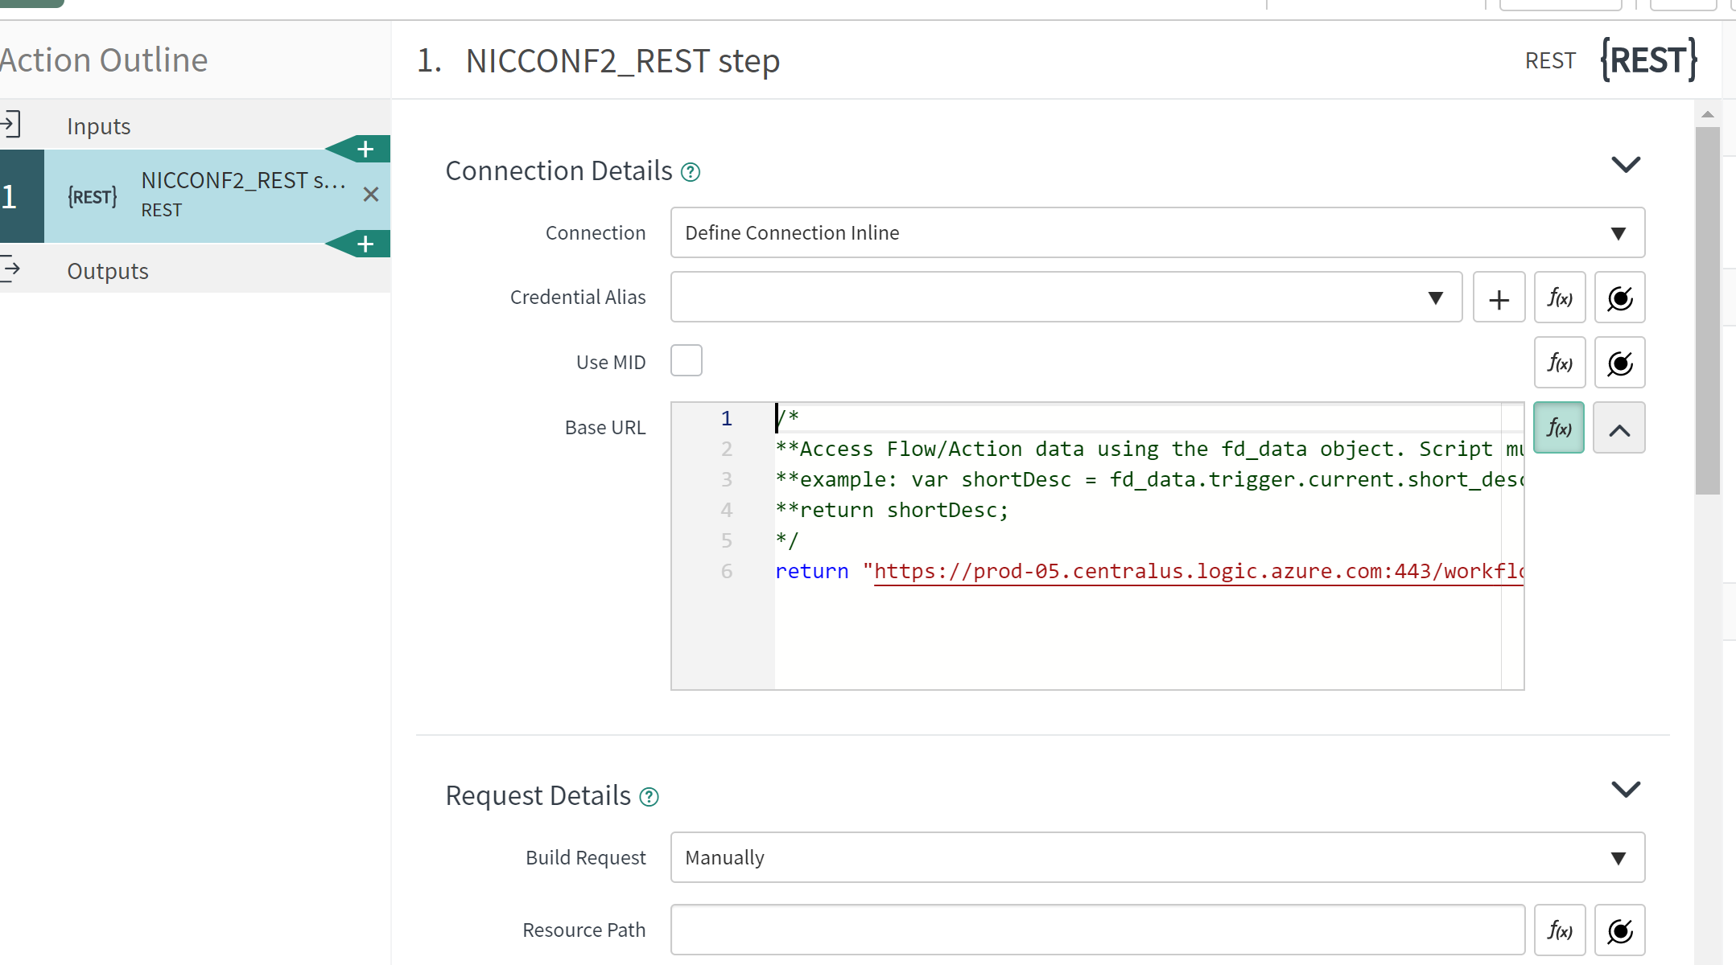

HTTP Post, and content type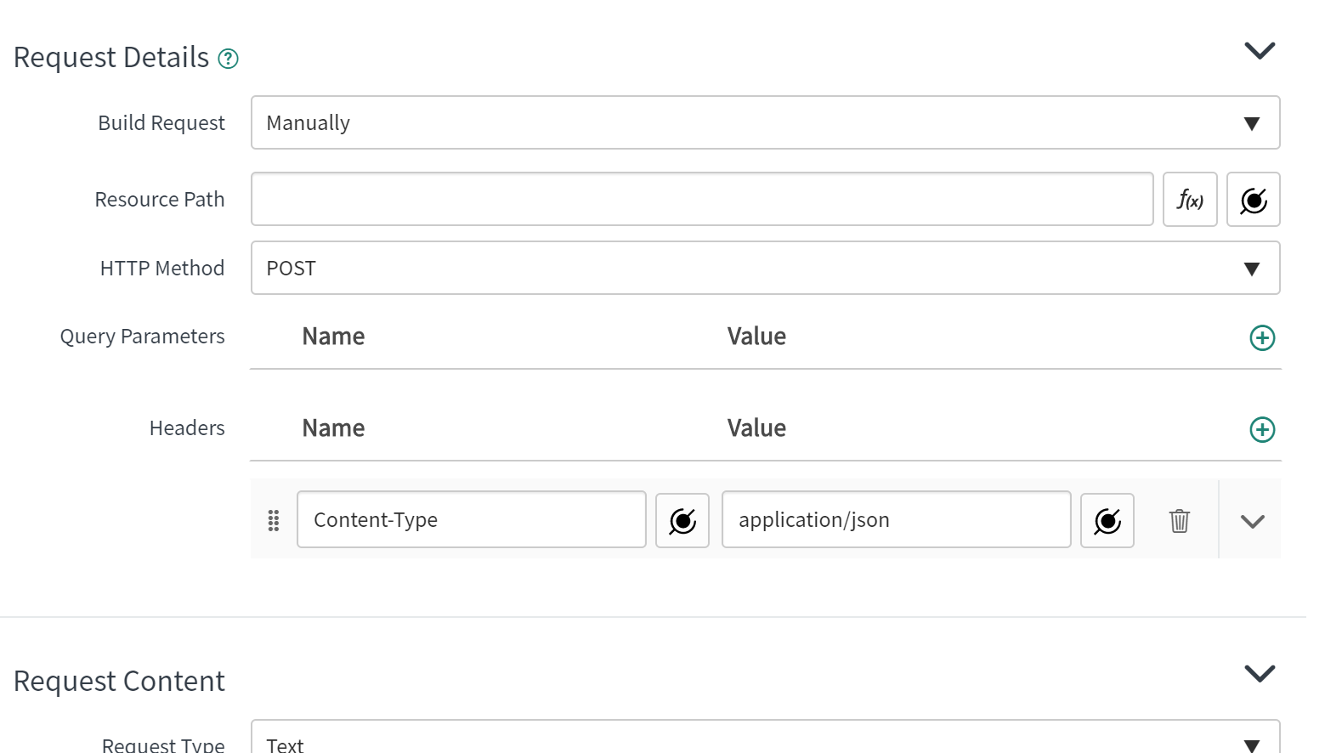

RequestContent: 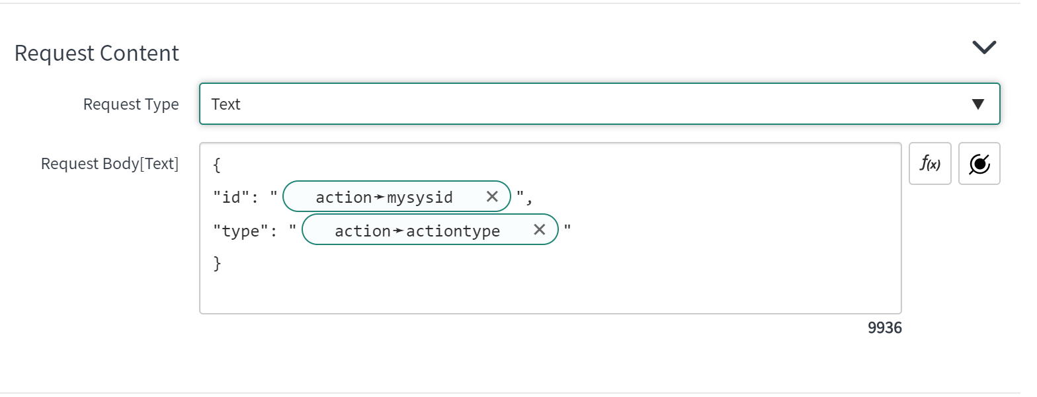

{

"id": "",

"type": ""

}

TEST!

Create ServiceNow Flow “NICCONF4_EnrichIncident”

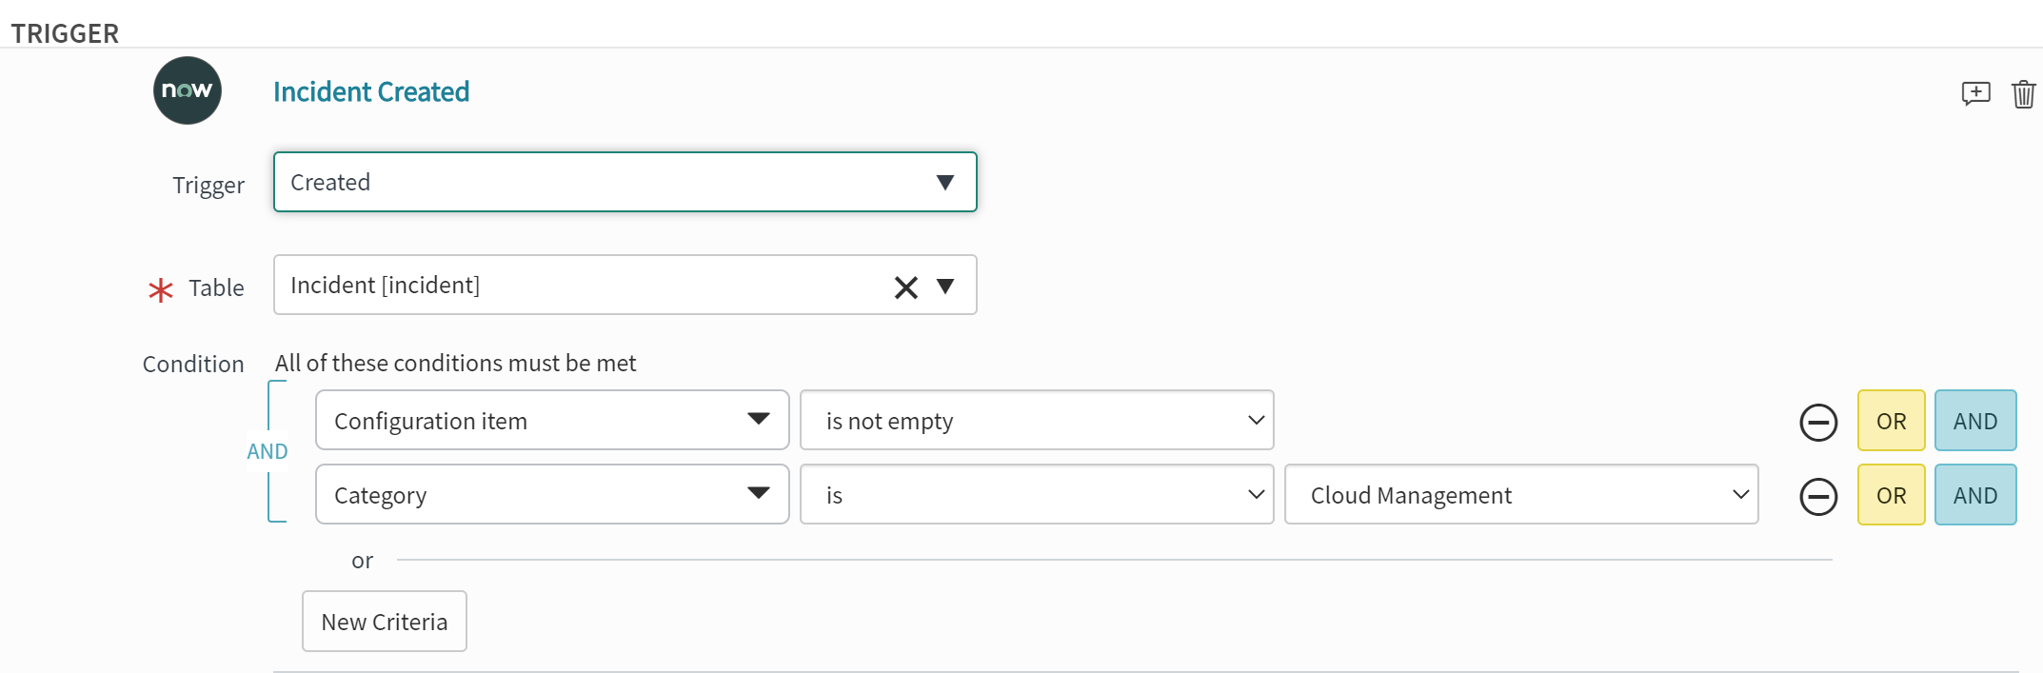

Add a comment

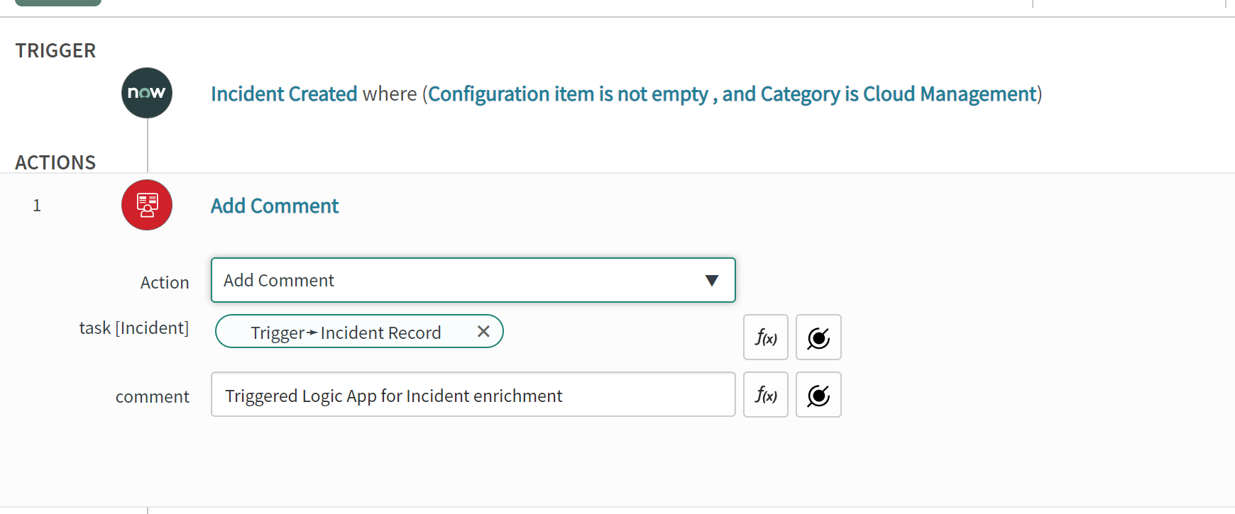

Configure action:

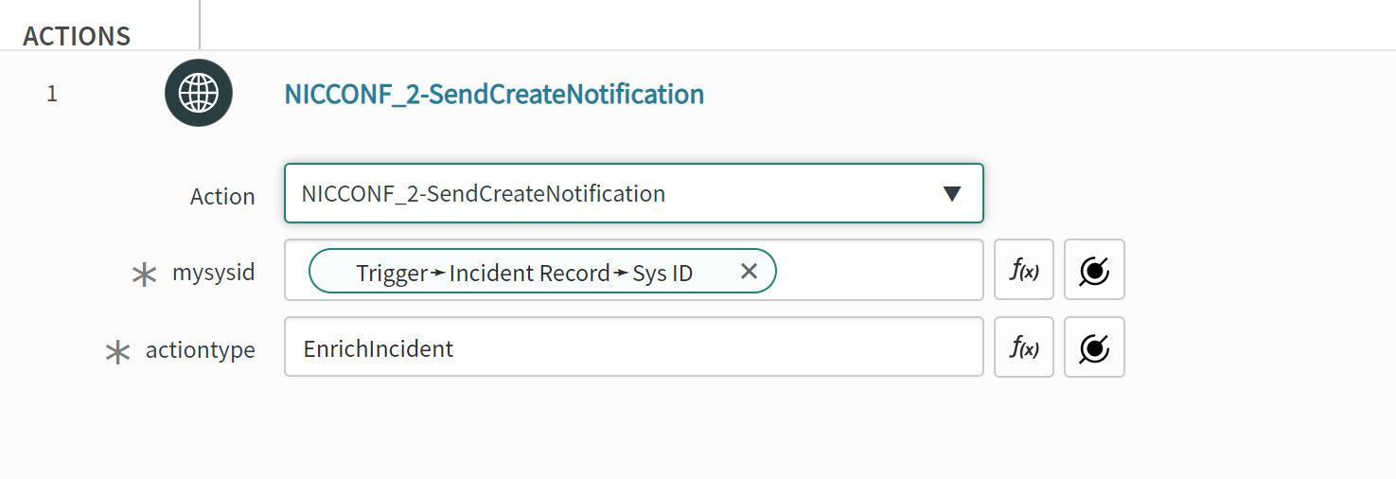

Test

Save

Activate

Create a new inc for test

1. Grant rights for logic app to run in resource group
   1. Enable system assigned identity – “IDENTITY” Link
   2. 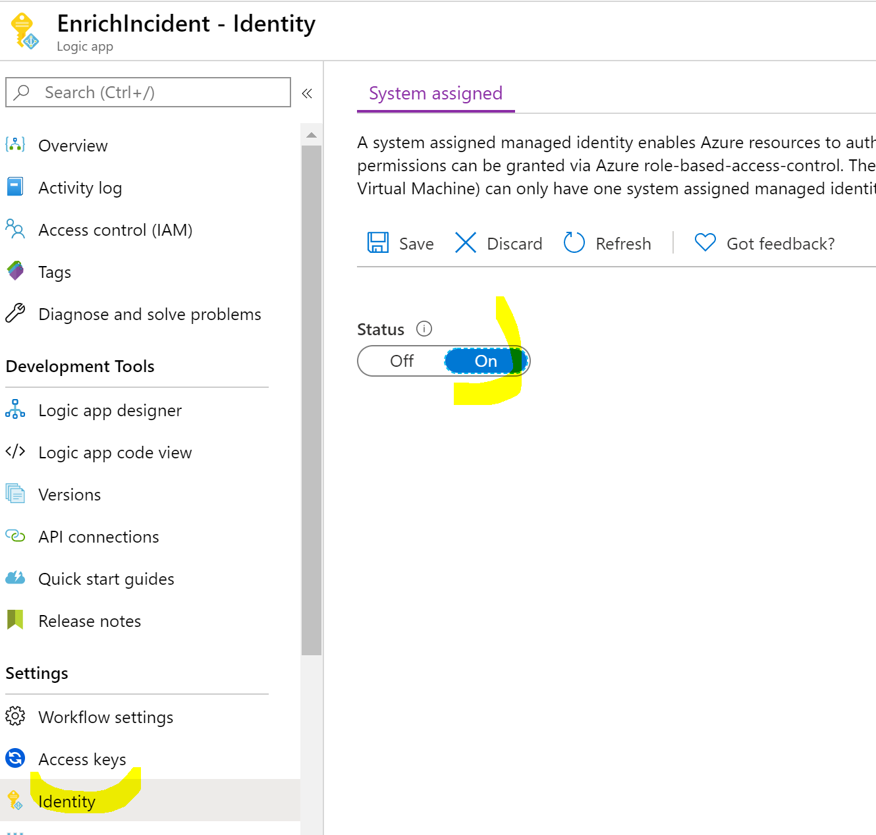
   3. Go to IAM to add role

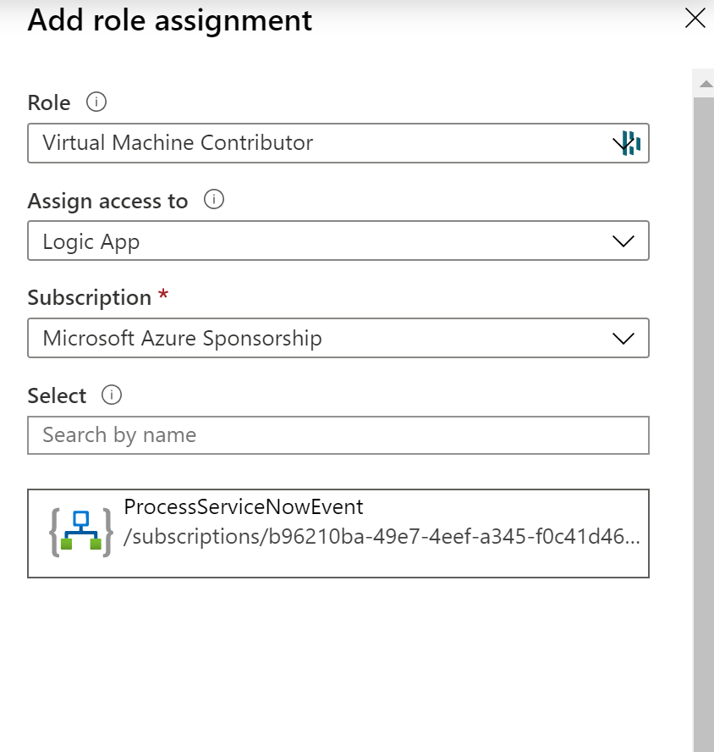

1. Build out logic app

Create a switch based on the type - = EnrichIncident

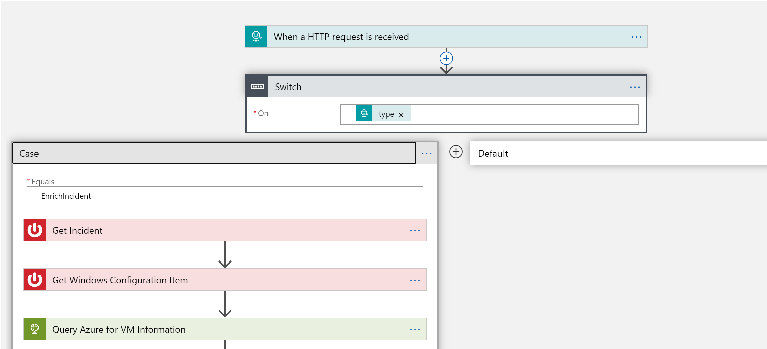

Query to get incident

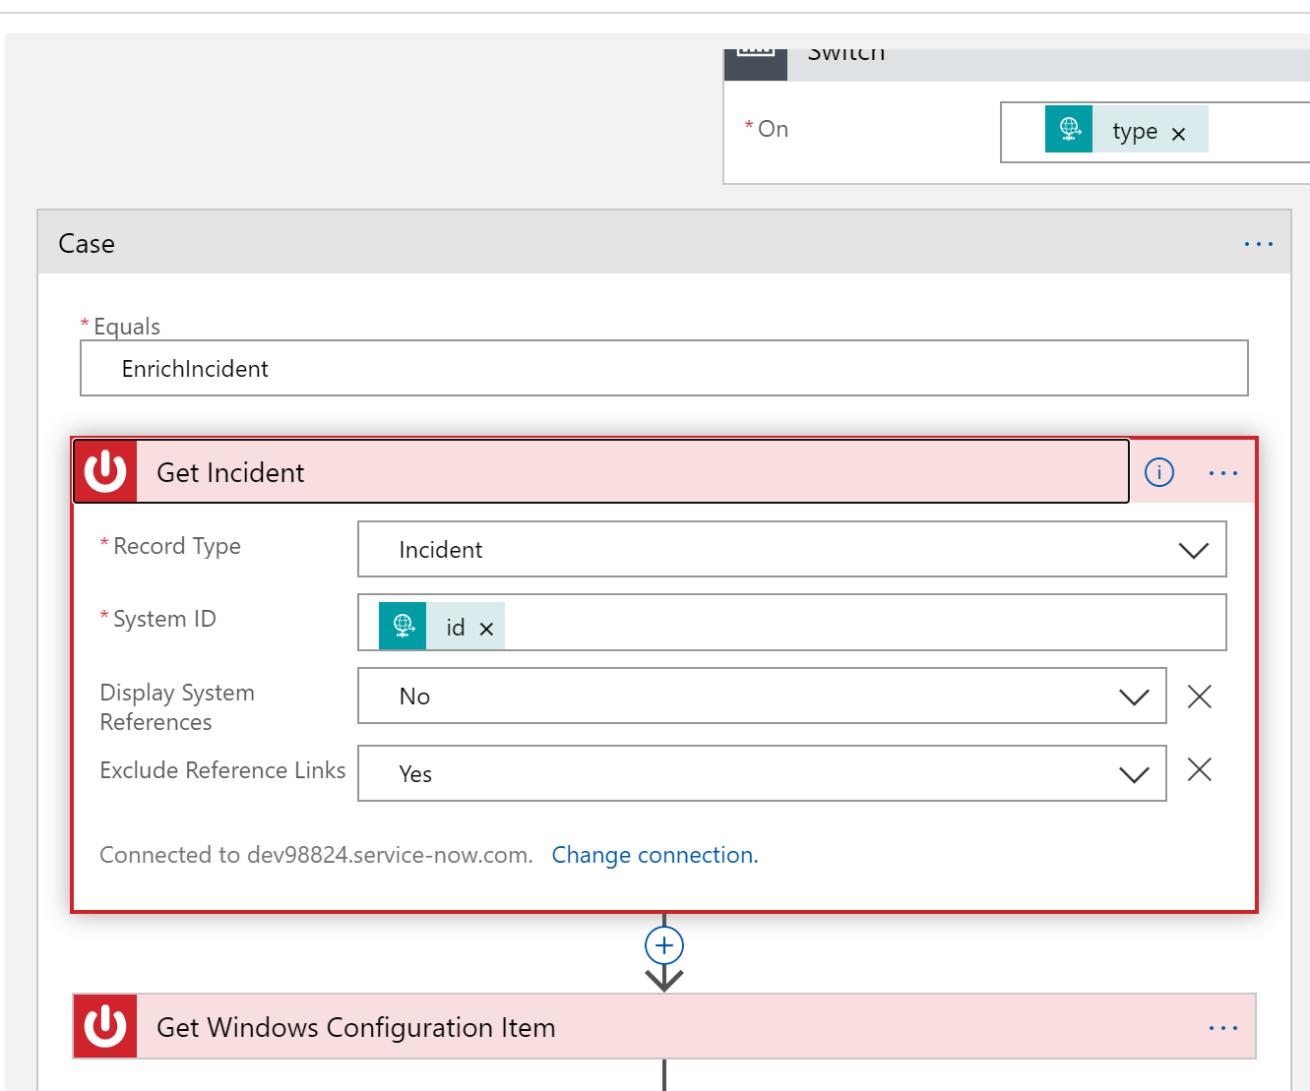

Query to get the configuration item information

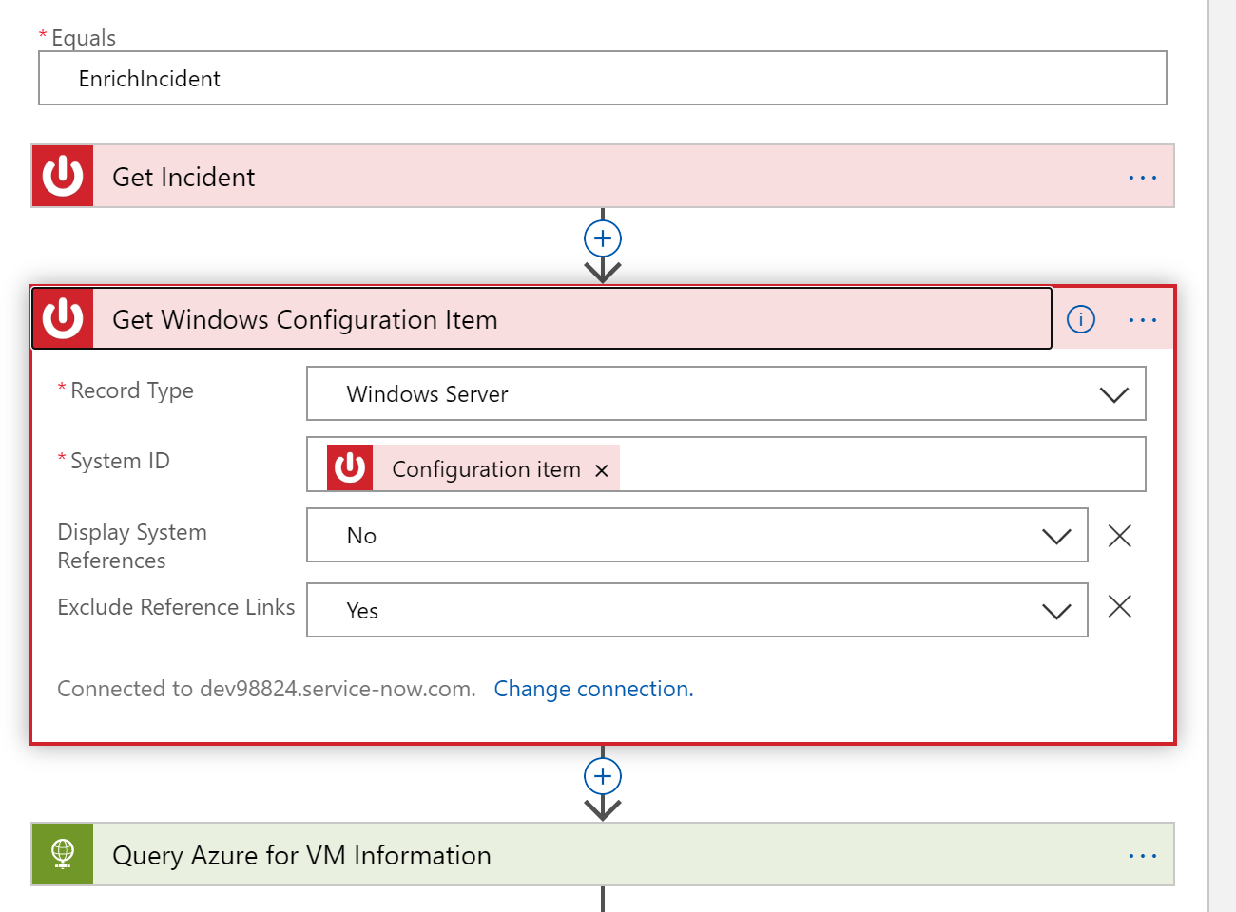

Now we get to query the VM instance

Show how to ‘try it out’ for querying VM info via REST:

<https://docs.microsoft.com/en-us/rest/api/compute/virtualmachines/instanceview>

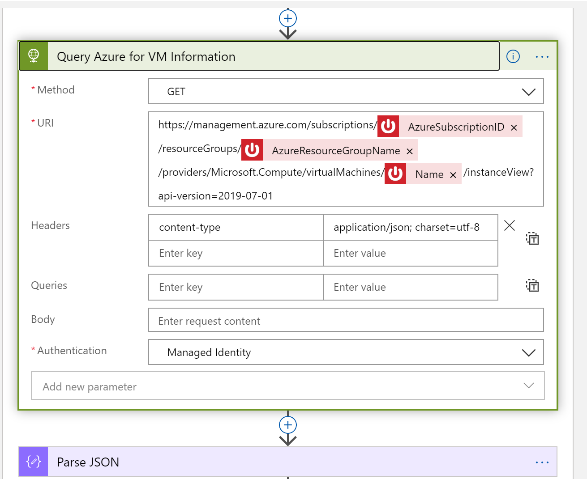

Parse the output

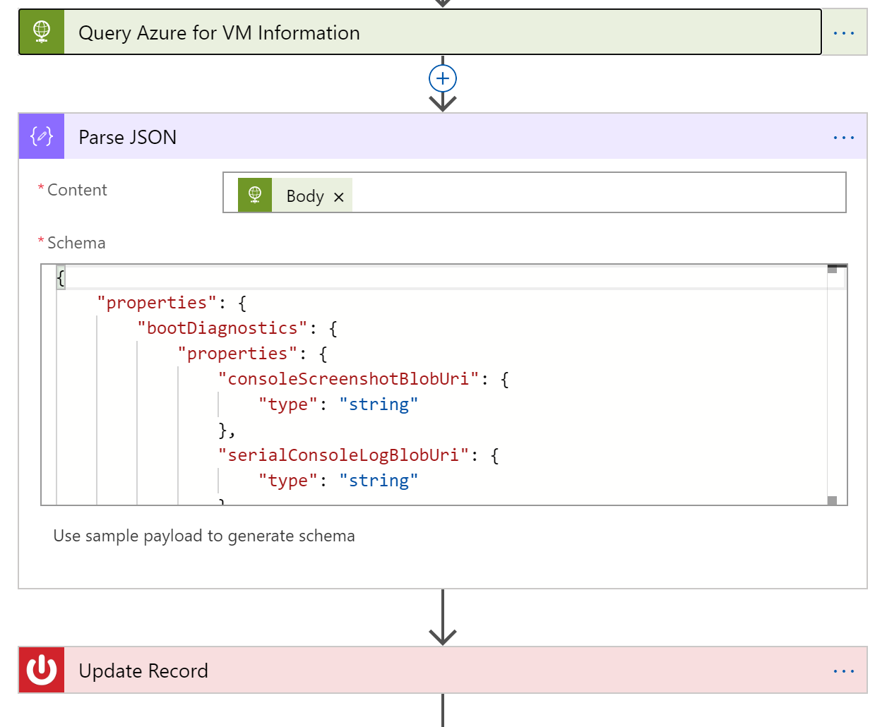

Update the record

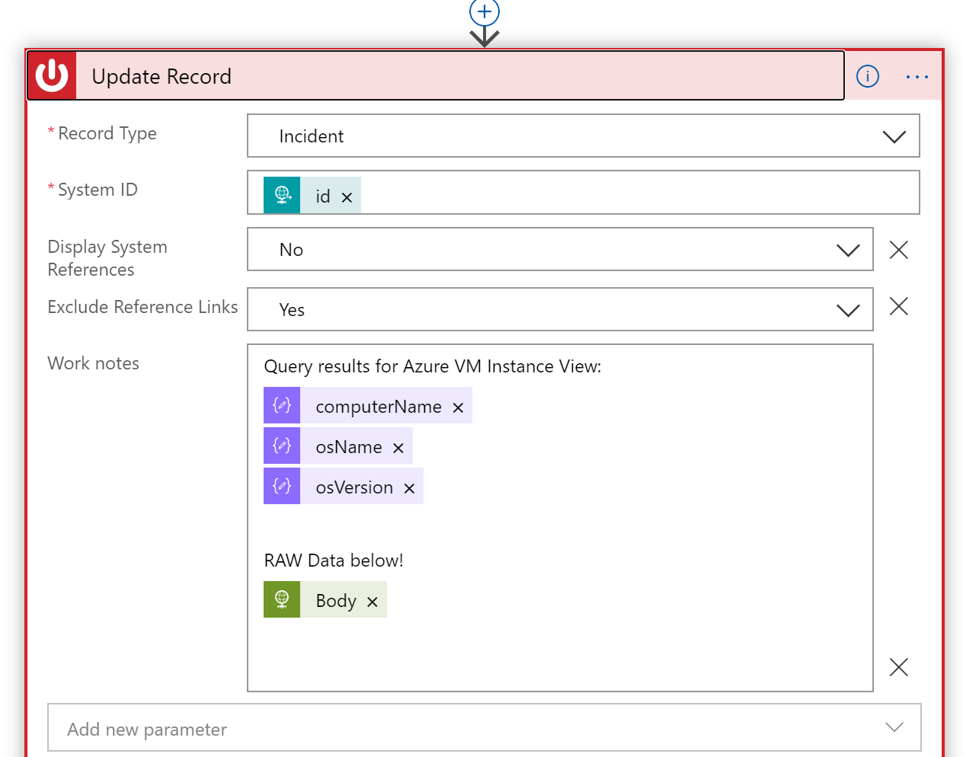

Now query to get the IP Information using ‘run command’

<https://docs.microsoft.com/en-us/rest/api/compute/virtual%20machines%20run%20commands/runcommand>

{

"commandId": "IPConfig"

}

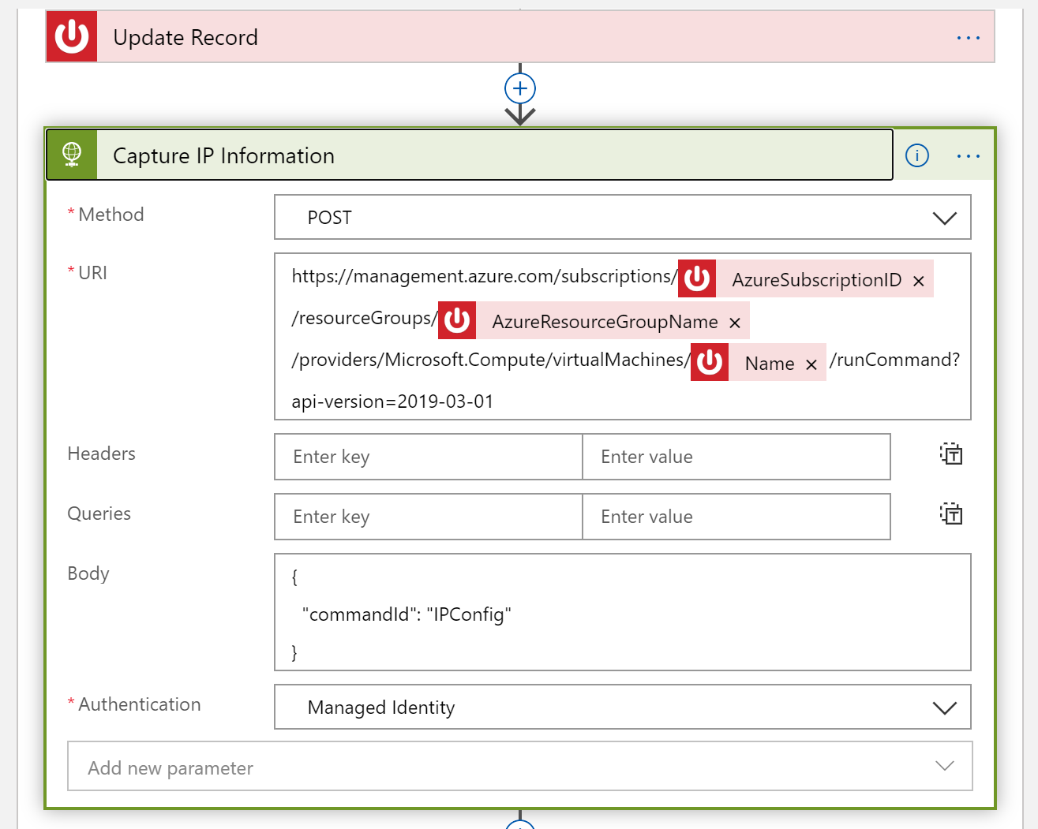

Update the incident with the raw data from ipconfig

